**Wireless communications Course Project 2017**

Names:

John Emad Nashed 34-14858

Khaled Hossam 34-14766

Ahmed Bassem 34-3514

Ahmed Mohamed Elsaied 34-7640

**Matlab code:**

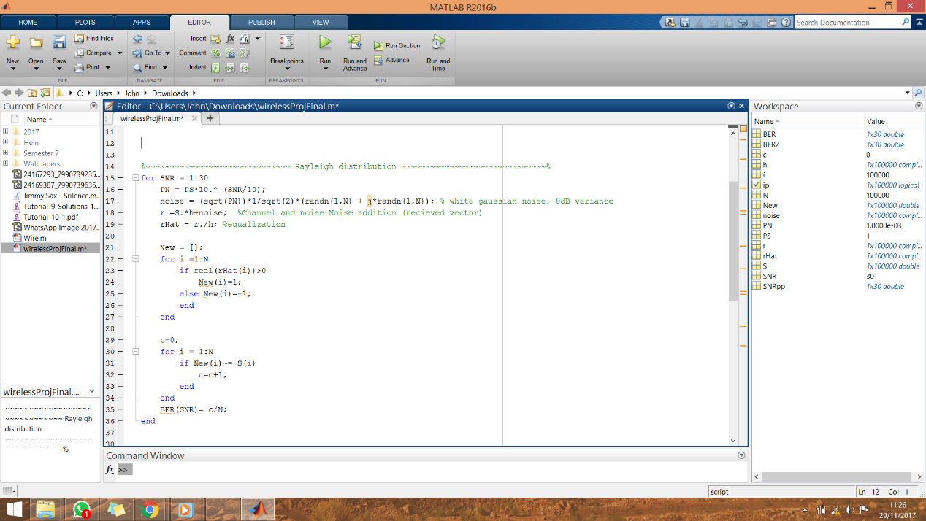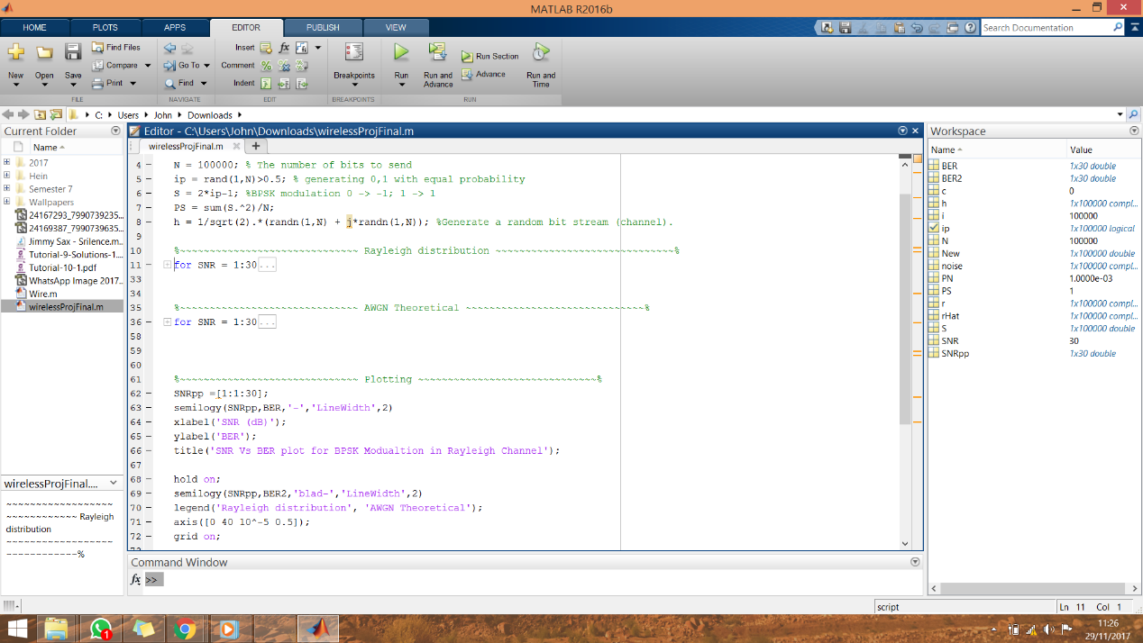

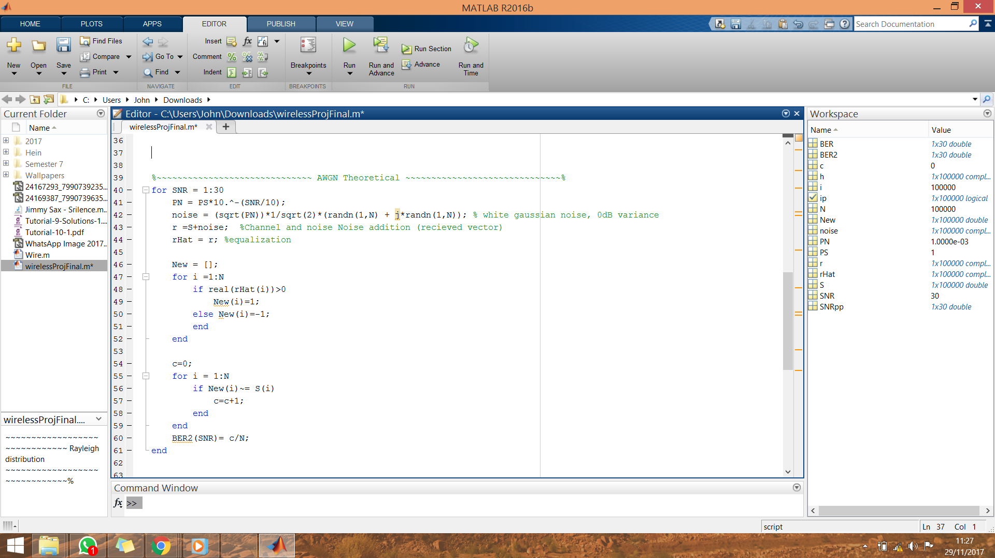

**Figure 1 Containing AWGN and Rayleigh distribution (BER vs SNR):**

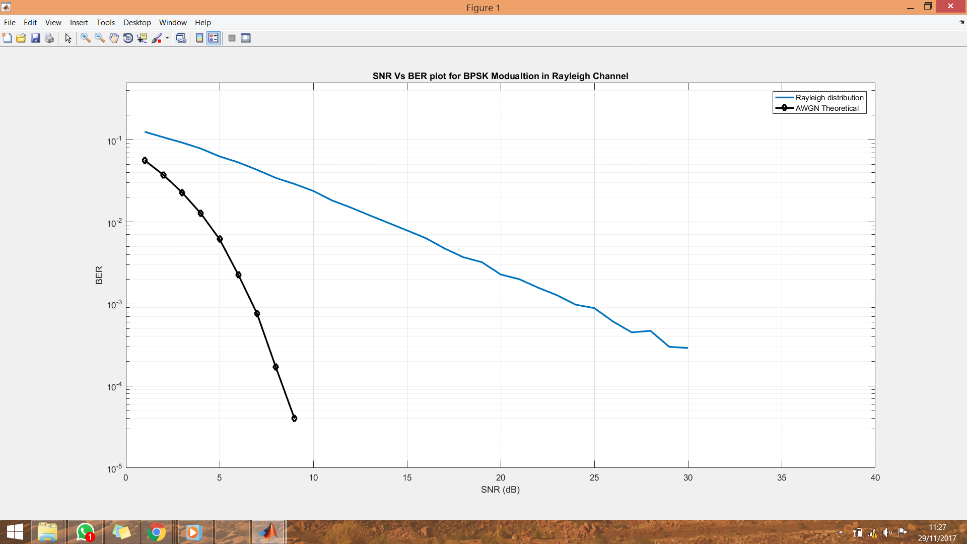

**Comments:**

My comment lies here